Question Bank-1
School of Applied and Basic Sciences
Course Name: Linear Algebra and Differential Equations Course Code: BBS01T1003
Serial No. |  | Questions |  | CO |  | Bloom’s Taxonomy Level |  | Difficulty Level |  | Competitive Exam Question Y/N |  | Area |  | Topic |  | Unit |  | Marks
1 | Define Matrix and Determinant with example. |  | CO1 |  | KI |  | L |  | N |  | Matrices |  | Basic Concepts of Matrix and Vector, types, algebra |  | 1 |  | 2
2 | Give three differences between Matrix and Determinant. |  | CO1 |  | K2 |  | L |  | N |  | Matrices |  | Basic Concepts of Matrix and Vector, types, algebra |  | 1 |  | 2
3 | Perform the requested computation: (7.1/261/K)  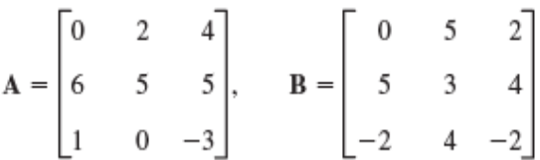, Calculate 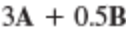 |  | CO1 |  | K3 |  | L |  | N |  | Matrices |  | Basic Concepts of Matrix and Vector, types, algebra |  | 1 |  | 2
4 | Perform the requested computation: (7.2/270/K)  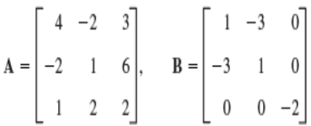, 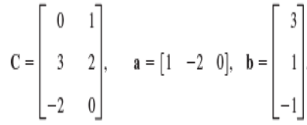  Calculate the following expression: 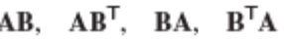, 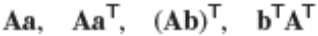 |  | CO1 |  | K3 |  | L |  | N |  | Matrices |  | Basic Concepts of Matrix and Vector, types, algebra |  | 1 |  | 2
5 | Give an example of a system of 3 Homogeneous linear equations in 4 unknowns. |  | CO1 |  | K2 |  | L |  | N |  | Sys of equ |  | Homogeneous system |  | 1 |  | 2
6 | 6.1 Give an example of a system of 2 Non-homogeneous linear equations in 2 unknowns.  6.2 Give an example of homogeneous system of linear equation of 3 variable which has non zero solution. |  | CO1 |  | K2 |  | L |  | N |  | Sys of equ |  | Homogeneous system |  | 1 |  | 2
7 | Find the value of constant, if the matrix 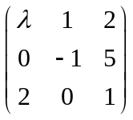is singular. |  | CO1 |  | K3 |  | M |  | N |  | Determinant |  | singular |  | 1 |  | 2
8 | Perform the given sequence of elementary row operations on 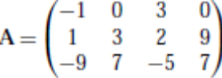 : Multiply row 3 by 4, then add 14 times row1 to row2 and then interchange rows 3 and 2. (7.2/202/O) |  | CO1 |  | K3 |  | M |  | N |  | Elementary Transformation |  | Elementary row transformation |  | 1 |  | 2
9 | Find the value of constant, if the matrix has rank 2. |  | CO1 |  | K3 |  | M |  | N |  | Rank of Matrix |  | Basic Concept of rank |  | 1 |  | 2
10 | Find the rank of a 3X2 matrix, whose every element is unity. |  | CO1 |  | K2 |  | M |  | N |  | Rank of Matrix |  | Basic Concept of rank |  | 1 |  | 2
11 | For What value of the rank of the following matrix is 2  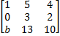. |  | CO1 |  | K3 |  | M |  | N |  | Rank of Matrix |  | Basic Concept of rank |  | 1 |  | 2
12 | For what value of , the inverse of the matrix 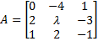 exists. |  | CO1 |  | K3 |  | M |  | N |  | Inverse of a Matrix |  | Basic Concept of Inverse |  | 1 |  | 2
13 | If A is an orthogonal Matrix, then find 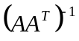where 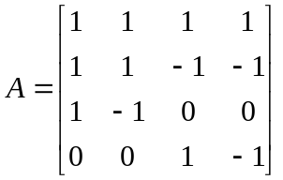 |  |  |  | K2 |  | M |  | Y |  | CO1 |  | Basic Concept of Inverse |  | 1 |  | 2
14 | Find the product of the Matrices 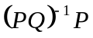. |  | CO1 |  | K2 |  | M |  | Y |  | Inverse of a Matrix |  | Basic Concept of Inverse |  | 1 |  | 2
15 | What will be the rank of the product matrix AB, if A & B are non-zero row and column matrix respectively with same number of elements? |  | CO1 |  | K2 |  | H |  | N |  | Rank of Matrix |  | Basic Concept of rank |  | 1 |  | 2
16 | If a matrix A has order 5X3 and the product AB is 5X7. what is the size of B? |  | CO1 |  | K2 |  | H |  | N |  | Basic concept on matrices |  | Algebra of Matrices |  | 1 |  | 2
17 | If 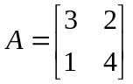the find the value of A(adjA) |  | CO1 |  | K2 |  | M |  | N |  | Basic concept on matrices |  | Adjoint of Matrices |  | 1 |  | 2
18 | If B is a non singular matrix and A is a square matrix then what is the value of 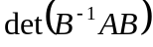. |  | CO1 |  | K2 |  | H |  | N |  | Inverse of Matrices |  | Basic concept |  | 1 |  | 2
19 | Finb rank? (a) 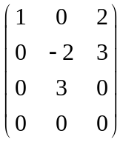, (b)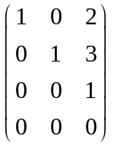, (c) 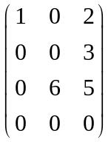, (d) 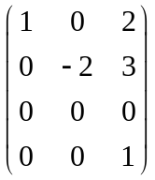. |  | CO1 |  | K3 |  | M |  | N |  | Rank of Matrix |  | To find rank |  | 1 |  | 6
20 | Let 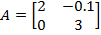 and 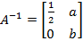 then prove that (a + b) = |  | CO1 |  | K3 |  | H |  | Y |  | Inverse of Matrices |  | Basic Concept |  | 1 |  | 6
21 | Find rank 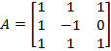 |  | CO1 |  | K2 |  | H |  | Y |  | Rank of Matrix |  | To find rank |  | 1 |  | 6
22 | Determine the rank of the matrix 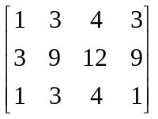 |  | CO1 |  | K2 |  | M |  | N |  | Rank of Matrix |  | To find rank |  | 1 |  | 6
23 | Show that matrix A.A’ is a symmetric matrix |  | CO1 |  | K2 |  | M |  | N |  | Basic concept of Matrices |  | Symmetric Matrix |  | 1 |  | 6
24 | Given 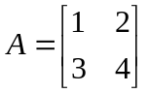 find a most general matrix B such that AB=0. |  | CO1 |  | K2 |  | M |  | N |  | Basic concept of Matrices |  | Multiplication of Matrx |  | 1 |  | 6
25 | A matrix A is said to be involutary if A²=I. Give an example of involuntary matrix. Your answer should not be an identity matrix. |  | CO1 |  | K2 |  | H |  | N |  | Basic concept of Matrices |  | Involuntary Matrix |  | 1 |  | 6
26 | Find the value of ‘k’ for which the given set of equations has infinite solutions  (3k-8) x + 3y + 3z = 0, 3x + (3k-8) y + 3z=0, 3x+3y+(3k-8) z=0 |  | CO1 |  | K2 |  | M |  | N |  | Sys of equ |  | homogeneous |  | 1 |  | 6
27 | Check whether the rank is 3 of Matrix 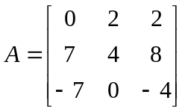or not. If no find the rank. |  | CO1 |  | K2 |  | L |  | Y |  | Rank of Matrix |  | Basic concept of rank |  | 1 |  | 6
28 | Under what condition, the rank of the following matrix A is 3? Is it possible for the rank to be 1? Why?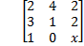 |  | CO1 |  | K2 |  | M |  | N |  | Rank of Matrix |  | Basic concept of rank |  | 1 |  | 6
29 | Find the rank of a 3×3 matrix C (=AB), found by multiplying a non-zero column matrix Aof size 3×1 and a non-zero row matrix B of size 1×3. |  | CO1 |  | K2 |  | H |  | Y |  | Rank of Matrix |  | Basic concept of rank |  | 1 |  | 6
30 | For a given 2 × 2 matrix A, it is observed that  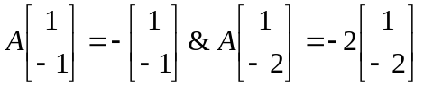Find Matrix A |  | CO1 |  | K2 |  | H |  | Y |  | Basic operation of Matrix |  | Algebra of Matrix |  | 1 |  | 6
31 | Show that the system of linear equations has no solution. 4x + 2y = 7 2x + y = 6 |  | CO1 |  | K2 |  | M |  | Y |  | Sys of equ |  | Concept of No solution |  | 1 |  | 6
32 | Find the inverse of the following matrix by row operations  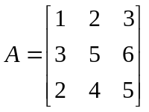 |  | CO1 |  | K2 |  | M |  | N |  | Inverse of Matrix |  | To find inverse |  | 1
33 | Find the rank of the following matrices: (a)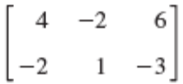,(b) 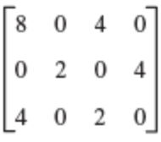, (c) 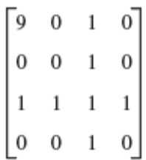, |  | CO1 |  | K3 |  | M |  | N |  | Rank of Matrix |  | To find rank |  | 1 |  | 6
34 | Determine whether the given system of linear equations is consistent. If consistent, find solution: (7.5, 7.6/219,226/O) (a)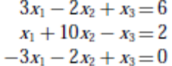, (b) 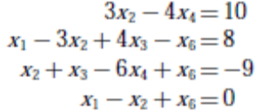, (c) 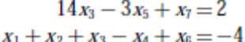,(d) 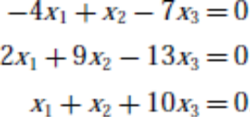 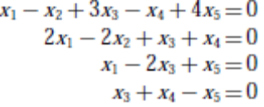 (e) |  | CO1 |  | K3 |  | M |  | N |  | Sys of equ |  | Non homogeneous Equ |  | 1 |  | 9/10
35 | Determine the values of constant ‘k’ for which the system of equations: (J&I) has (i) only trivial solution, (ii) non-trivial solution also |  | CO1 |  | K3 |  | M |  | N |  | Sys of equ |  | Homogeneous Equ |  | 1 |  | 9/10
36 | Find the values of and for which the system of linear equations : (J&I)  , has (a) a unique solution, (b) infinite number of solutions, (c) no solution. |  | CO1 |  | K3 |  | M |  | N |  | Sys of equ |  | Non homogeneous Equ |  | 1 |  | 9/10
37 | Find the inverse of the following matrices by applying elementary operations(Or by Gauss-Jordan method):(7.7/231/O) (a)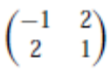, (b) 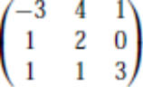 , (c) 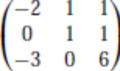d) 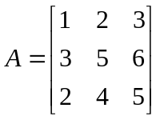 |  | CO1 |  | K3 |  | M |  | N |  | Inverse of Matrix |  | To find inverse |  | 1 |  | 9/10
38 | Use a matrix inverse to find the unique solution of the system: (7.7/232/O) 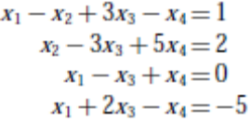 |  | CO1 |  | K3 |  | M |  | N |  | Sys of equ |  | Non homogeneous Equ |  | 1 |  | 9/10
39 | Find the inverse of the following matrices by Gauss Jordan elimination:  (i)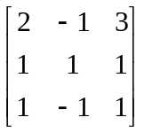 (ii)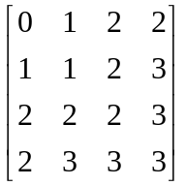 |  | CO1 |  | K3 |  | M |  | N |  | Inverse of Matrix |  | To find inverse |  | 1 |  | 9/10
40 | Test the consistency of the following system of equations. Find the solution/s, if consistent:.(a),  (b)(c). |  | CO1 |  | K3 |  | M |  | N |  | Sys of equ |  | Check the consistency & solve |  | 1 |  | 9/10
41 | Find the condition of k such that the matrix has an inverse obtain A⁻¹ for K = 1  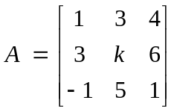 |  | CO1 |  | K3 |  | M |  | N |  | Inverse of Matrix |  | Basic concept |  | 1 |  | 9/10
42 | Find the solution of the following system of equations: |  | CO1 |  | K2 |  | M |  | N |  | Sys of equ |  | Homogeneous |  | 1 |  | 9/10
43 | Investigate the values of a and b so that the system has  (i)Unique solution (ii) No solution (iii) Infinite no. of solutions |  | CO1 |  | K3 |  | M |  | N |  | Sys of equ |  | Nonhomogeneous |  | 1 |  | 9/10
44 | Find the inverse of the matrix  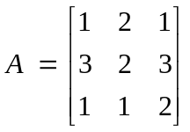 by using E-transformation |  | CO1 |  | K3 |  | M |  | N |  | Inverse of Matrix |  | To find rank |  | 1 |  | 9/10
45 | For what values of α and β the following simultaneous equations have an infinite number of solutions? x + y + z = 5; x + 3y + 3z = 9; x + 2y + αz = β |  | CO1 |  | K3 |  | H |  | Y |  | Sys of equ |  | Nonhomogeneous |  | 1 |  | 9/10
46 | For the Matrix A= 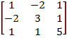 verify that (i)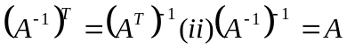 |  | CO1 |  | K2 |  | M |  | N |  | Inverse of Matrix |  | Properties and concept |  | 1 |  | 9/10
47 | Let A and B be any nonsingular matrices of same order then prove that 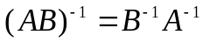. |  | CO1 |  | K2 |  | M |  | N |  | Inverse of Matrix |  | Properties and concept |  | 1 |  | 9/10
48 | Show that the matrix A=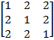 satisfies the matrix equation 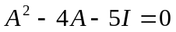. Hence find 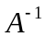and adj(A). |  | CO1 |  | K3 |  | M |  | N |  | Inverse of Matrix |  | Properties and concept |  | 1 |  | 9/10
49 | Let 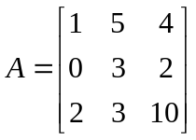, 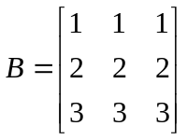find rank of A, rank of B, rank of A+B, rank of AB, rank of BA. |  | CO1 |  | K3 |  | M |  | N |  | Rank of Matrix |  | Basic concept |  | 1 |  | 9/10
50 | Show that the only real value of , for which the system  has non-zero solution is 6 and solve them for = 6. |  | CO1 |  | K3 |  | H |  | N |  | Sys of equ |  | Nonhomogeneous Equ |  | 1 |  | 9/10
51 | Solve the system of equations by Cramer rule 2x + 3y + z = 9,4x + y = 7,x – 3y – 7z = 6 |  | CO1 |  | K3 |  | M |  | Y |  | Cramer’s rule |  | To solve the system of equ solution |  | 1 |  | 9/10
52 | Show that the system of equations  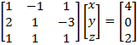 has a unique solution. Solve this system using by (i)Gauss elimination method |  | CO1 |  | K3 |  | M |  | N |  | Sys of equ |  | Nonhomogeneous Equ |  | 1 |  | 9/10
53 | Solve (51) by Cramer’s rule |  | CO1 |  | K3 |  | M |  | N |  | Cramer’s rule |  | Nonhomogeneous Equ |  | 1 |  | 9/10
54 | Solve the system of equations by calculating the inverse. x+y+z+u=0, x+y+z-u=4, x+y-z+u=-4, x-y+z+u=2. |  | CO1 |  | K3 |  | M |  | N |  | Sys of equ |  | Nonhomogeneous Equ |  | 1 |  | 9/10
55 | Show that the equations 3x + 3y + 2z = 1, x + 2y = 4, 10y + 3z =-2 and 2x – 3x – z = 5 are consistent hence obtain the solution for x, y and z. |  | CO1 |  | K3 |  | M |  | N |  | Sys of equ |  | Nonhomogeneous Equ |  | 1 |  | 9/10
56 | Solve the system of equations by Cramer rule. a)  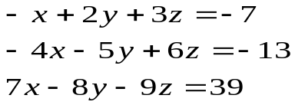 b)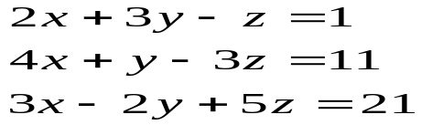 c)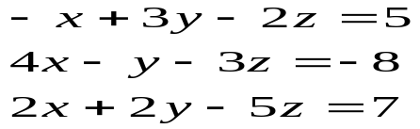 |  | CO1 |  | K3 |  | M |  | N |  | Cramer’s rule |  | Nonhomogeneous Equ |  | 1 |  | 9/10
\

Signature of Course Coordinator:
Signature of PC:
Signature of Dean:
IQAC:
Appendix II :
Bloom’s Taxonomy Levels Distribution of Questions in Question Bank
School of Basic and Applied Sciences Date : 11-03-2022
Course Name : Linear Algebra and Differential Equations Course Code : BBS01T1003
Serial No. | Bloom’s Taxonomy Level | Percentage Distribution
1 | Knowledge | 10%
2 | Understand | 30%
3 | Apply | 60%

Signature of Course Coordinator:
Signature of PC:
Signature of Dean:
IQAC:

Appendix III :
Bloom’s Taxonomy Levels Distribution of Questions in Question Bank
School of Basic and Applied Sciences Date : 11.03.2022
Course Name : Linear Algebra and Differential Equations Course Code : BBS01T1003

Serial No. | Difficulty Level | Percentage Distribution
1 | Low | 20%
2 | Medium | 60%
3 | High | 20%

Signature of Course Coordinator:
Signature of PC:
Signature of Dean:
IQAC:

